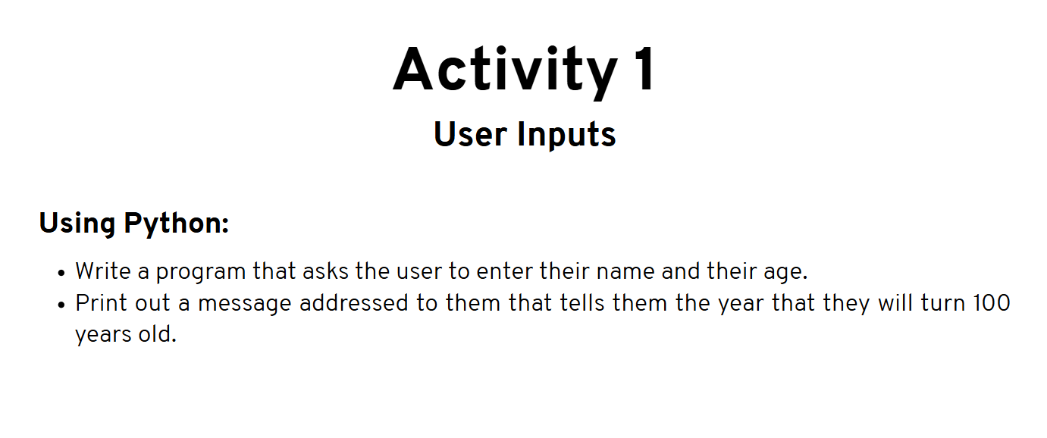

Activity 1

name = input( "What is your name: " )

age = int( input( "How old are you: " ) )

year = str( ( 2024 - age ) + 100 )

print( name + " will be 100 years old in the year " + year )

Output:

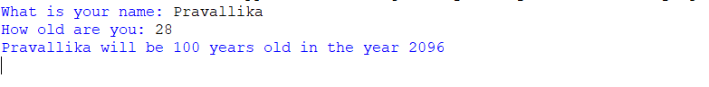

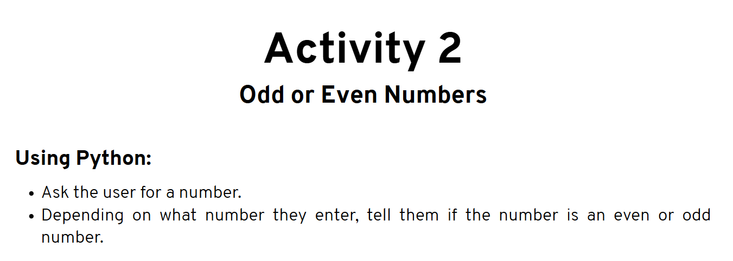

Activity2

Program:

num = int(input("Enter a number: "))

mod = num % 2

if mod > 0:

print("You picked an odd number.")

else:

print("You picked an even number.")

Output:

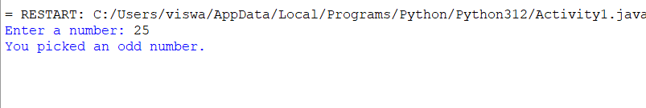

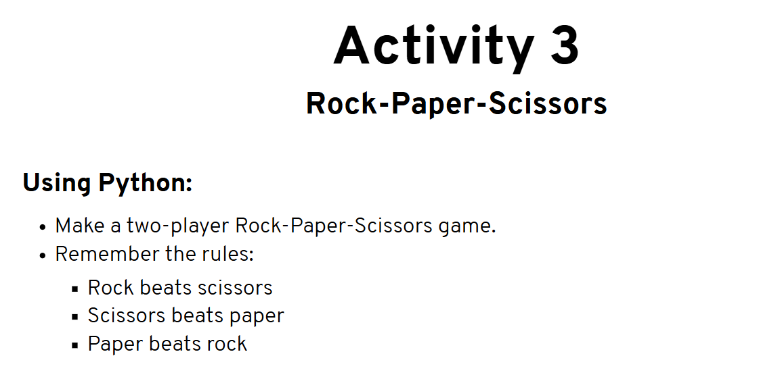

Activity3

Program:

# Get the users names

user1 = input("What is Player 1's name? ")

user2 = input("What is Player 2's name? ")

# Get the users choices

user1_answer = input(user1 + ", do you want to choose rock, paper or scissors? ").lower()

user2_answer = input(user2 + ", do you want to choose rock, paper or scissors? ").lower()

# Run the algorithm to see who wins

if user1_answer == user2_answer:

print("It's a tie!")

elif user1_answer == 'rock':

if user2_answer == 'scissors':

print("Rock wins!")

else:

print("Paper wins!")

elif user1_answer == 'scissors':

if user2_answer == 'paper':

print("Scissors win!")

else:

print("Rock wins!")

elif user1_answer == 'paper':

if user2_answer == 'rock':

print("Paper wins!")

else:

print("Scissors win!")

else:

print("Invalid input! You have not entered rock, paper or scissors, try again.")

Output: 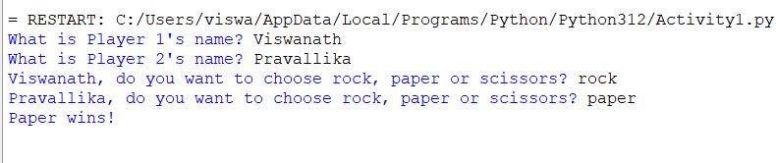

Activity4

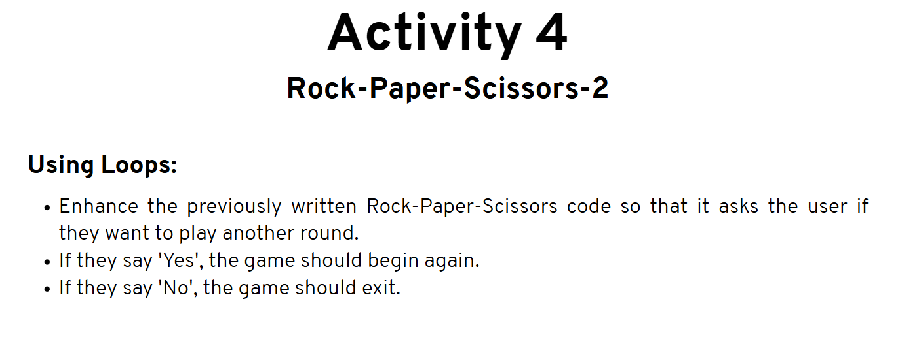

**Program:**

# Get the names of the users

user1 = input("What is Player 1's name? ")

user2 = input("What is Player 2's name? ")

# While looping endlessly

while True:

# Ask User1's choice

user1_answer = input(user1 + ", do you want to choose rock, paper or scissors? ").lower()

# Ask User2's choice

user2_answer = input(user2 + ", do you want to choose rock, paper or scissors? ").lower()

# Run the algorithm to see who wins

if user1_answer == user2_answer:

print("It's a tie!")

elif user1_answer == 'rock':

if user2_answer == 'scissors':

print("Rock wins!")

else:

print("Paper wins!")

elif user1_answer == 'scissors':

if user2_answer == 'paper':

print("Scissors win!")

else:

print("Rock wins!")

elif user1_answer == 'paper':

if user2_answer == 'rock':

print("Paper wins!")

else:

print("Scissors win!")

else:

print("Invalid input! You have not entered rock, paper or scissors, try again.")

# Ask them if they want to play again

repeat = input("Do you want to play another round? Yes/No: ").lower()

# If they say yes, don't do anything

if(repeat == "yes"):

pass

# If they say no, exit the game

elif(repeat == "no"):

raise SystemExit

# If they say anything else, exit with an error message.

else:

print("You entered an invalid option. Exiting now.")

raise SystemExit

**Output:**

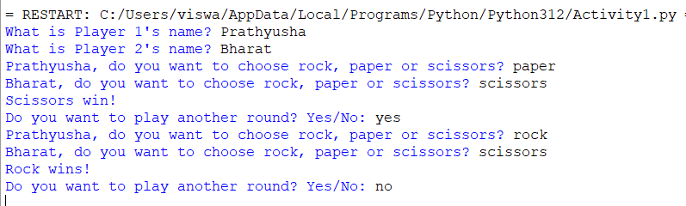

Activity 5

Multiplication Table:

**Program:**

num = int(input("Enter number: "))

for i in range(1,11):

print(num, ' * ', i, ' = ', num*i)

**Output:**

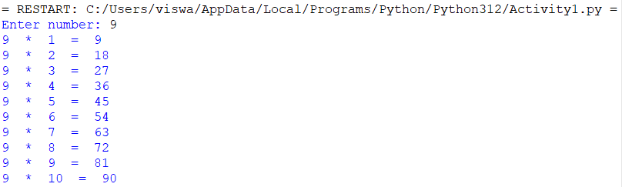

Activity6

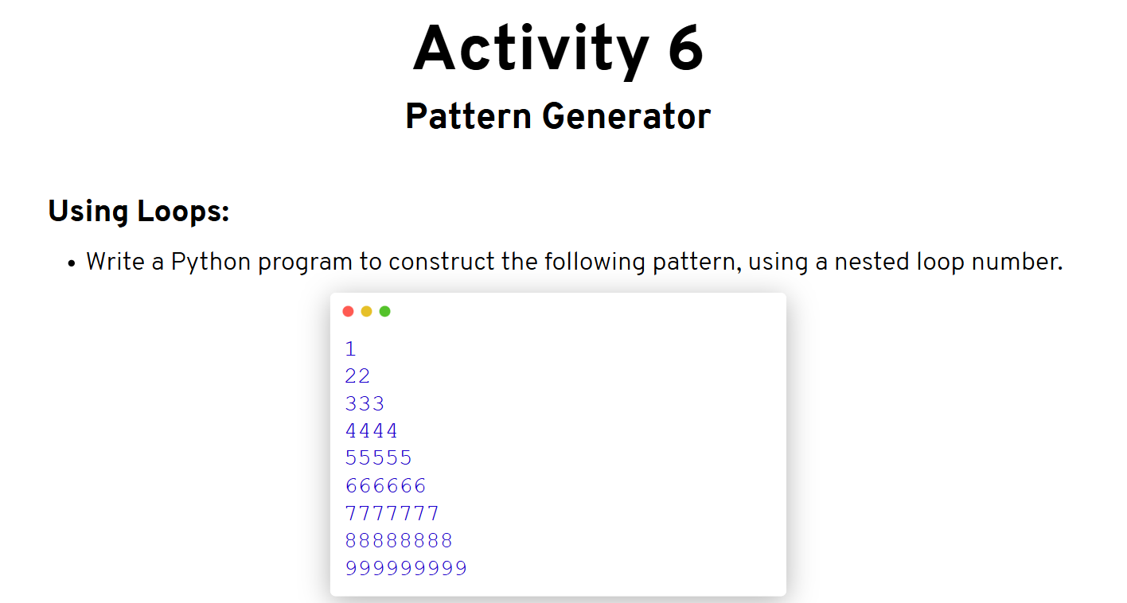

**Program:**

for i in range(10):

print(str(i) * i)

**Output:**

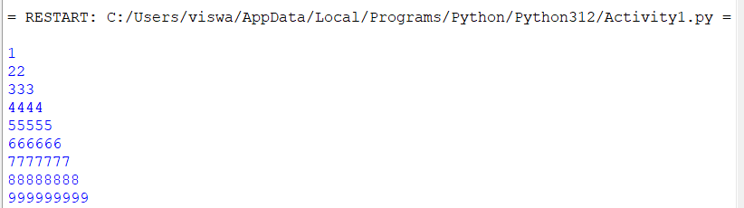

Activity7

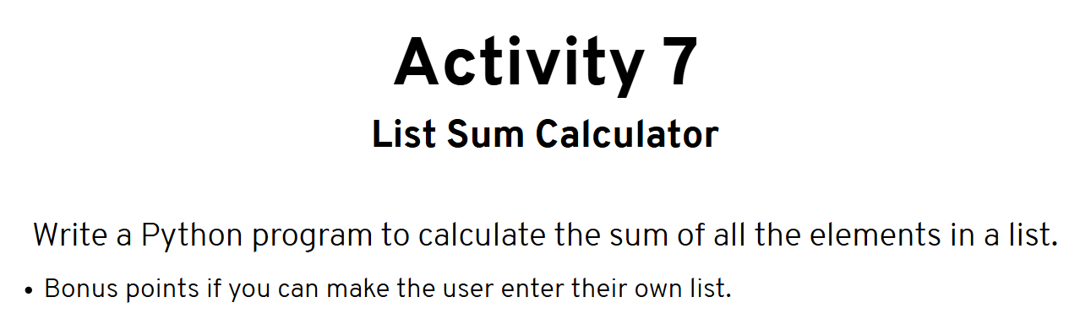

**Program:**

n = int(input("Enter no. of digits: "))

lst=[]

#ENter n no. of digits

for i in range(0, n):

num = int(input("Enter Number: "))

lst.append(num)

sum = 0

for num in lst:

sum += num

print("SUm of numbers on the list: ", sum)

**Output:**

